What is the Petty Cash Imprest system, and why would a business use it?
The Petty cash imprest system allows only the replenishment of the spend made. So, if you start the month with €100 in your petty cash float and spend €90 of that cash in the month, an amount of €90 will be then placed in your petty cash float to bring the balance of your petty cash float back to €100. The replenishment is credited to the primary cash account, usually a bank account (Dr - Petty Cash a/c, Cr - Bank a/c) and the debits will go to the respective expense accounts, based on the petty cash receipt dockets (Dr- Expense a/c, Cr - Petty Cash a/c). It exercises control, because the total of the receipts plus the remaining cash must always equal the designated Petty Cash Balance.

Start off by withdrawing 100 from the bank and putting it into the petty cash tin or lock box.
Do this by means of an account transfer transaction in SortMyBooks.

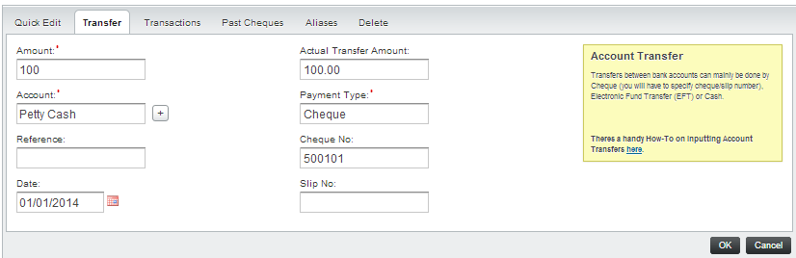

Looking at the Account Control Report for the Petty Cash account, you can see the above transaction created a debit entry of 100 in the petty cash account, increasing the account by 100.

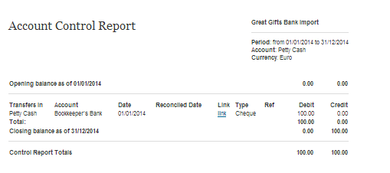
Looking at the Account Control Report for the Bookkeepers Bank account, you can see the above transaction created a credit entry of 100 in the Bookkeepers Bank account, reducing the account by 100.

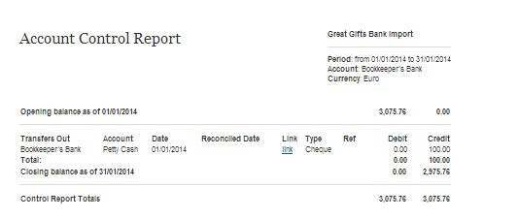

Now let’s start spending the Petty Cash:
As money is taken out of the Petty Cash tin, receipts are put in to replace it.

1 Jan - Tea 5.00
2 Jan - Stationery 20
3 Jan - Handyman 50

At all times, the receipts and money must add up to the balance of the Petty Control Account, in this case 100.

Periodically, commonly at month end, the receipts are entered into the accounts, and the Petty cash is topped up again. Example:

Entering the Receipts:

These are entered like any Purchase Invoice, recording the appropriate nominal code and any VAT amounts reclaimable.

It is important to note that the payments for these items need to be recorded as coming out of the Petty Cash Account.

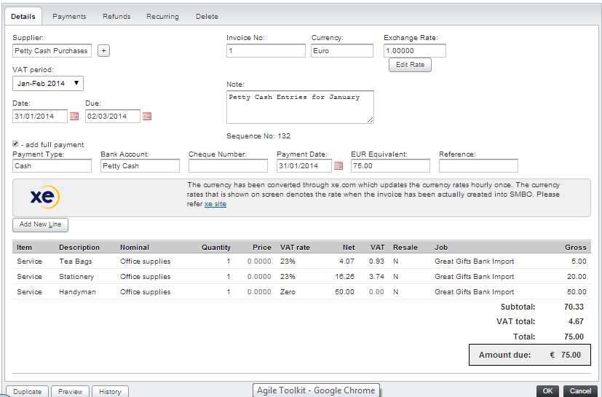

By looking at the Petty Cash Control Account, see that these items have credited the Petty Cash Account.

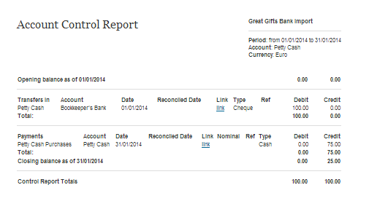
These amounts show as credits to the Petty Cash Account.
We can see by the closing balance that the Petty Cash Account is down to 25.
The final act is to replenish the Petty Cash account to bring it back up to 100.
Again this is recorded as an account transfer.
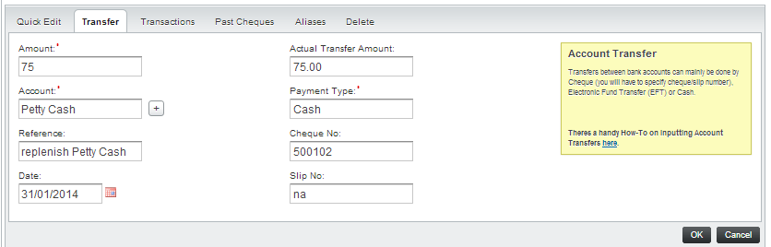

This amount once again debits the Petty Cash Account.

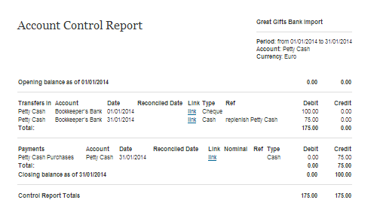
And credits the bank Account
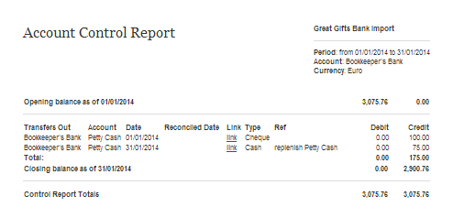

Looking at the Account Statement of the Petty Cash Account, it reads like a Bank Statement, showing the initial input of cash into the tin, the 75 spend during the month, and the replenishment amount to bring it back to 100.

