How to download Bank Of Ireland business if you do not have the download option enabled. The download option is available but I believe there is a charge for it of 70 per month.
If you are trading as a limited company and your online bank is Bank of Ireland you have my sympathies. We are also using this system and it is suffering from being one of the earliest versions and has not been updated. Having said that it is still worth going through this exercise to download your transactions and import them into SortMyBooks. It will save you a lot of time. Follow the steps below to first of all get the information out of BOI and then continue with instructions for getting it uploaded to SortMyBooks.
- Log-in to your online banking and click on the Reporting menu option and select Transaction report.
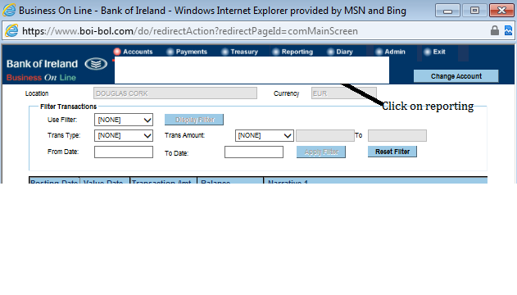
- Choose the date range that you want to run your reports from. This should ideally be the day after the last reconciliation date that you’ve completed in SortMyBooks. If this is your first time doing a bank reconciliation in SortMyBooks then choose the start date of your accounting year as the From Date and in the To Date enter a date either 1 month or 1 week after that. If you have a large volume of transactions it might be better to start with a week the first time that you do it. Once you’ve selected dates click on View Report.
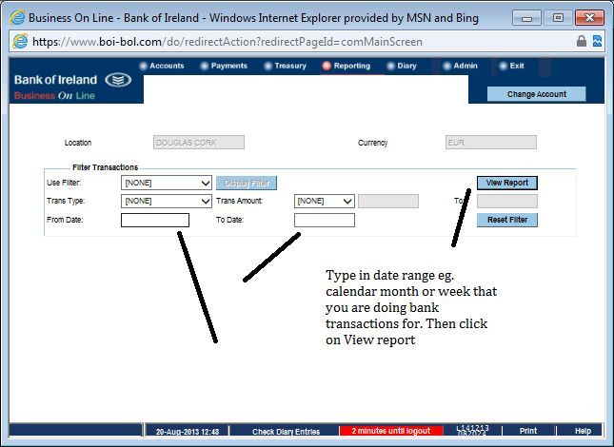
- Once the report comes up on screen you need to click with the mouse and drag down the screen to select all the entries. Drag the mouse to the bottom of the screen to select all of the entries. Once they are all highlighted then right-mouse click and select Copy and then open Excel.
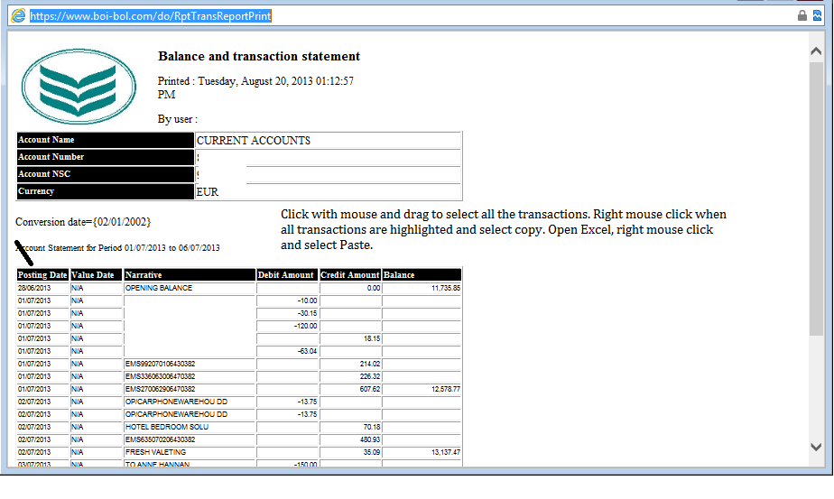
- When you have Excel open right-mouse click and select Paste to paste all the transactions.
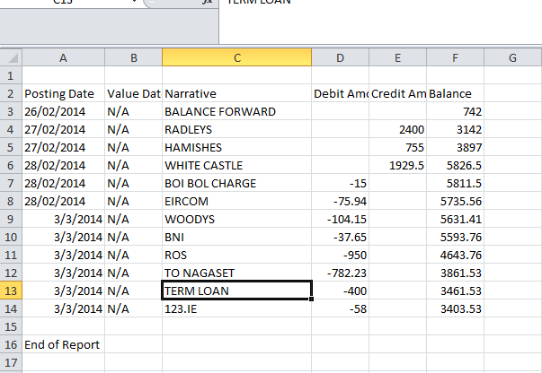
- Save the file on to your computer, it is a good idea to save it with a name that includes its date range because you’ll be doing this exercise probably once a month or maybe even more frequently.
- Log-in to SortMyBooks and click on Accounts and Statements and then click on your BOI account and on the next screen click on the Format dropdown and choose BOI – see screenshots below
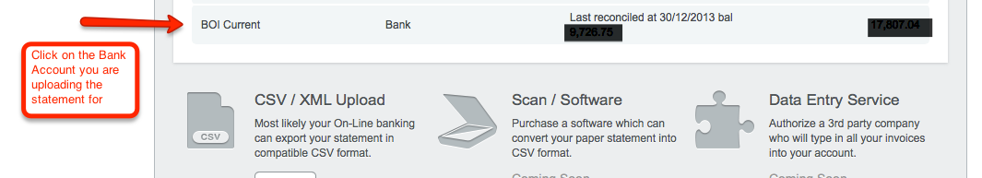
Select the format BOI and click on Upload Now and browse to where you saved your bank file.
