Allocating a payment to a Customer invoice.
There are two ways of adding a payment to a customer invoice.
Firstly if you have several invoices outstanding for a customer and you have received one payment to pay off these invoices you will proceed as follows:-
Go to Sales and then click on the Lodgments tab
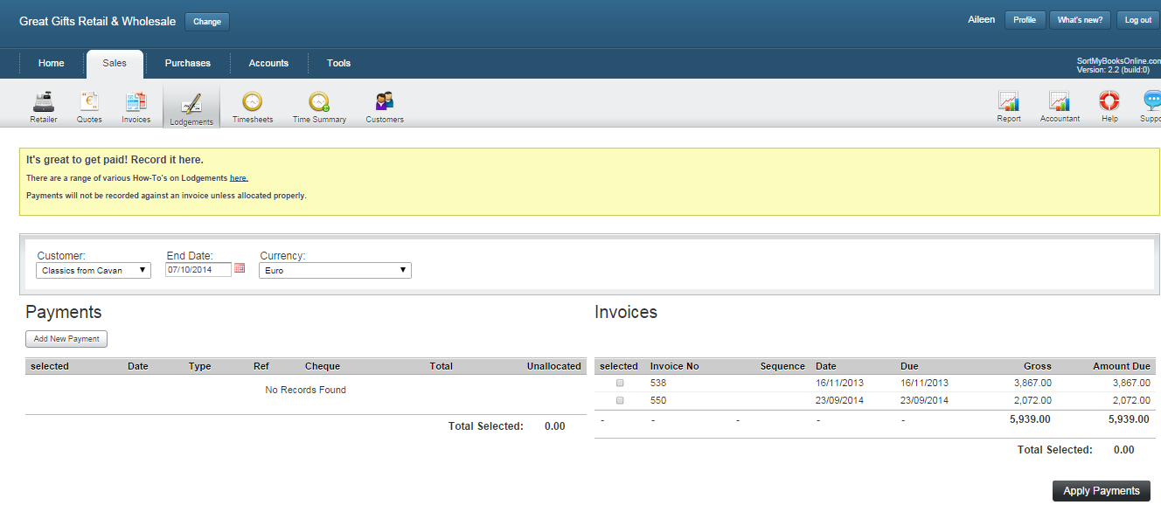
Select the Customers name from the dropdown Customer box and set the currency if required.
Click the Add New Payment button.
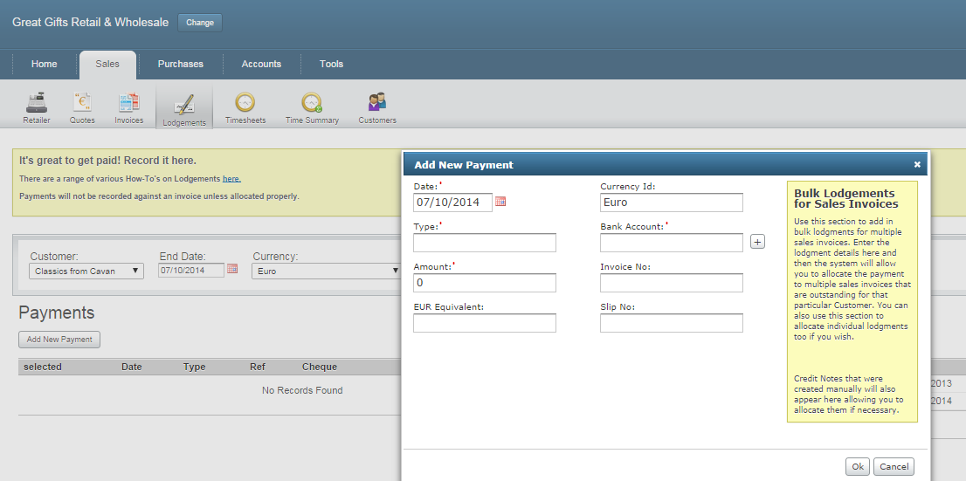
Add the date of the payment, the type of payment, the amount of the payment and the bank account you are putting the money into. Then add the slip/lodgement ref no and click OK

Tick the selected box on the payment and then tick the selected box on the invoice side to show which invoices you want to allocate the payment to, you will notice that the Total Selected balance on the payment section matches the Total Selected balance on the invoice section. Now click the Apply Payment button.

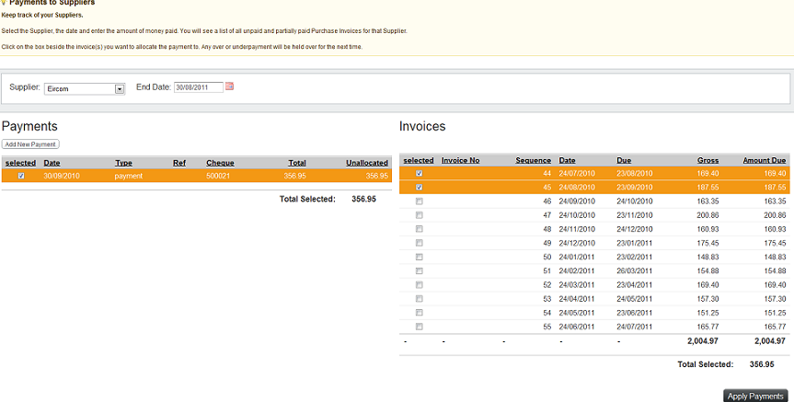
The second option , go to Sales and Invoices. Select the invoice you want to add the payment to
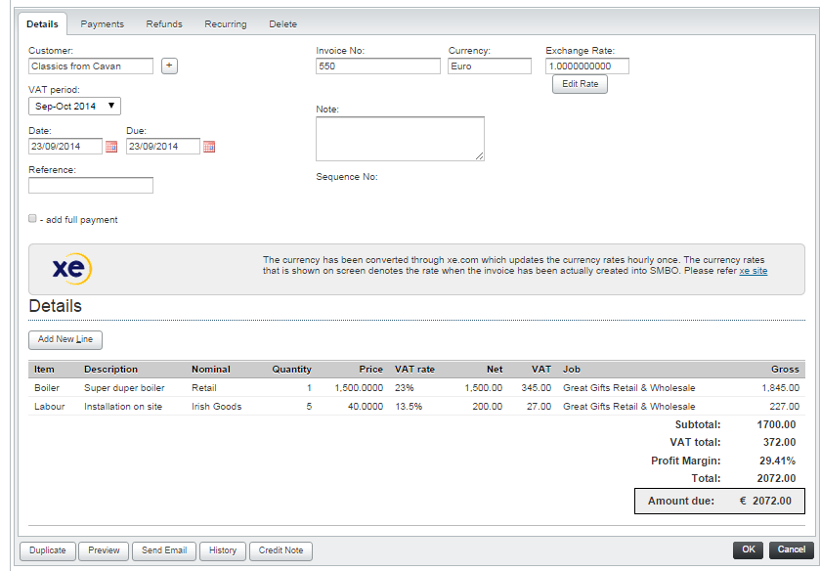
Then click the Payments button at the top of the screen.

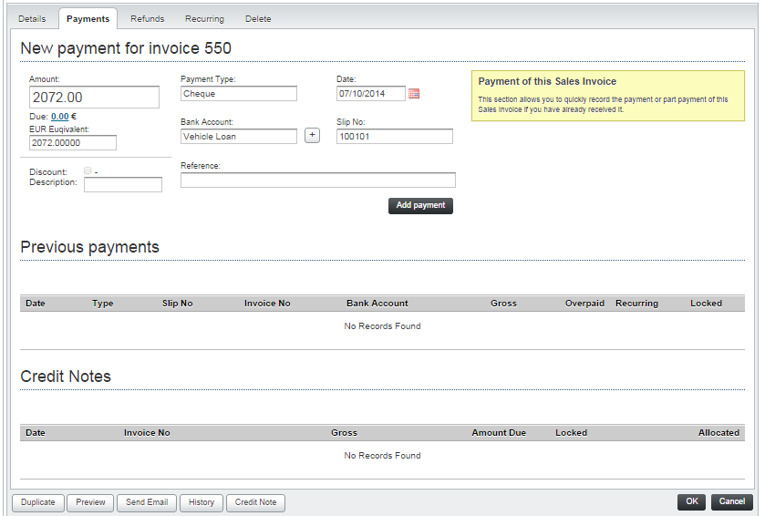
Click on the Due box and this will then put the payment amount in to the Amount box.
Select the type of payment, select the bank account and the date, if you have one put the slip number into the slip number box and then click the Add Payment button.

