Example: Your Base currency is Euro, you have an invoice in rubles and they are paying into your dollar account. To accomplish this you need to have an interim Euro contra account. You apply the payment for the foreign currency invoice from this Euro Contra Account and then transfer from the Euro contra to the US dollar account.
This method ensures all transactions are brought back to base currency for the accounts.

Bank Accounts to set up
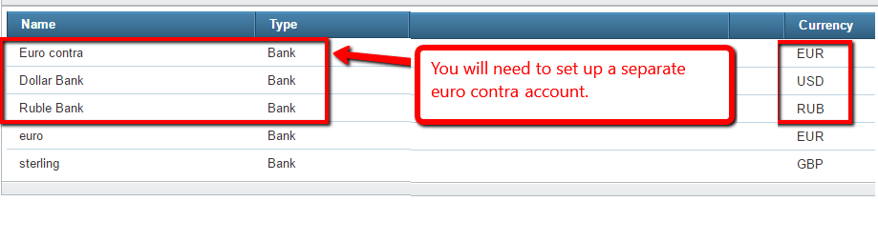
Foreign Currency Invoice
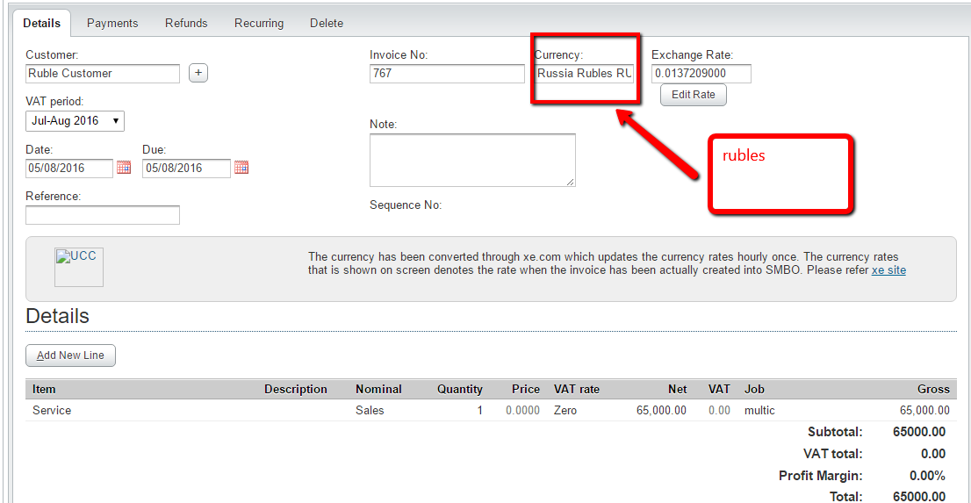

Payment for Foreign Currency Invoice
Note: Even though it is ultimately paid in dollars, it must be first recorded from the Euro Contra Account.
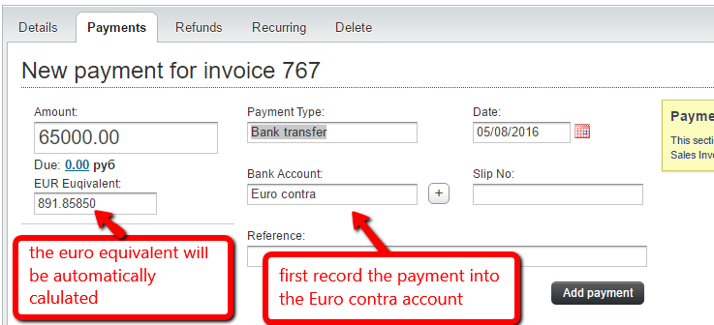

Transfer to second foreign currency
Go to Accounts, Bank, select the Euro Contra Account, and Transfer
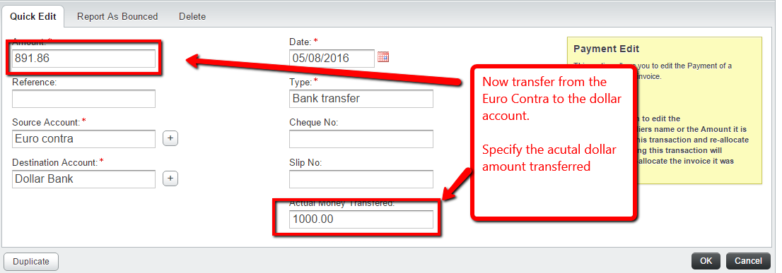

Final shot of bank accounts
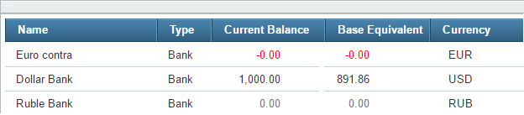

The Euro contra should always be zero at the end of the transaction sequence.
The dollar bank reflects receipt of payment of the $1000, which is the equivalent of the 65,000 rubles.
The base equivalent of the $1000 is the 891.86.

