Documents you will need:

VAT details filed with Revenue - Log onto your ROS system to get these.

PDFs or Printouts of saved Vat Returns – On completed your bimonthly VAT return you hopefully printed out to paper or PDF the VAT3 and drilldown details. Have these available for troubleshooting purposes.
https://sortmybooks.zendesk.com/entries/23293968-How-to-do-a-VAT-3-return

Reports from SortMyBooks:
Click Reports, VAT Reports, Vat Reconcilation. You will be able to match these figures with what you reported to the Revenue, and with any payments to or refunds from the Revenue. Drill down on any of the figures to find the details of the invoices and payments making up the figure. These should match the saved reports above and the details from your ROS system. If not, you will have to investigate where any discrepancy is coming from.

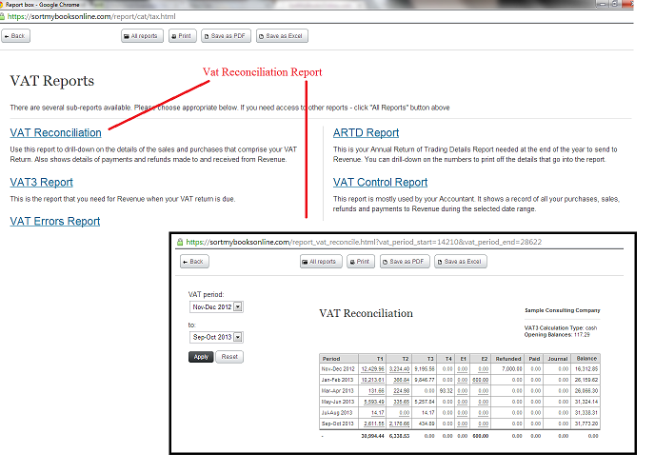

Common Pitfalls
Example: Current Reports do not match saved reports
If you followed the https://sortmybooks.zendesk.com/entries/23293968-How-to-do-a-VAT-3-return procedure then the system would not allow any additions, deletions or changes to transactions in the closed VAT period. However, if you did not close off a VAT period, it is possible that changes were made affecting the VAT period since you filed your VAT3s. Compare the current reports with the saved reports and drill down to any transaction discrepancy. Click on the audit log for the transaction and see when the change was made and who made it.
Example: Payments or Refunds on ROS do not match those in SortMyBooks
First verify that the payments are recorded accurately in SortMyBooks. The check to make sure that the Revenue applied your payment to the correct tax bill. For example, you made have made a payment for VAT that the Revenue applied to PAYE/PRSI.

