I am a subcontractor, and the Principal contractor has withheld some of my payment as instructed by the Revenue. How do I track this in my books?
First, set up your RCT withholding contra bank account:
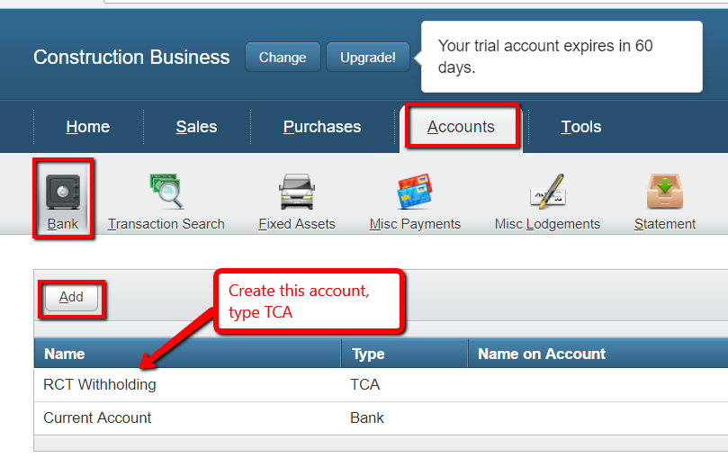
Then, go to your invoice and add the payment:
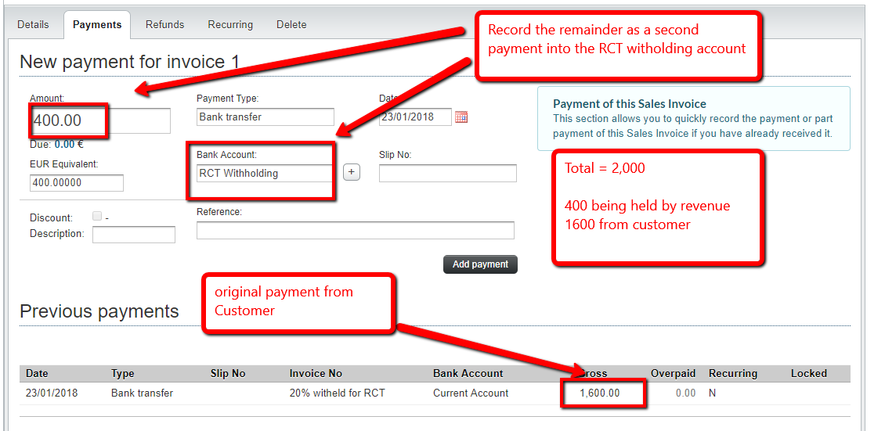

Your invoice is now shown as fully paid

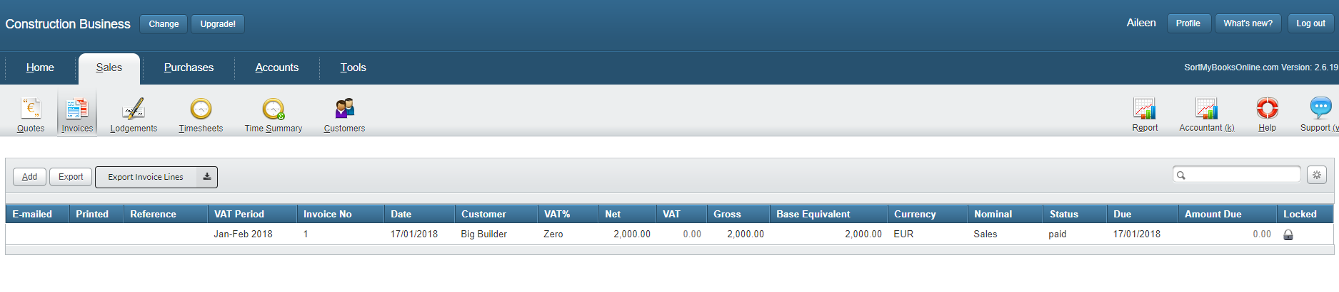
And your bank accounts reflect the full payment, the part that came directly to you, and the part that went to the Revenue.

